2011 American Transactions on Engineering & Applied Sciences.

American Transactions on
Engineering & Applied Sciences

http://TuEngr.com/ATEAS, http://Get.to/Research

Topic/Title of Article Concerning Development Works: Technical Works, Research Activities, Experiments, and Experiences

Boonsap Witchayangkoon^{a*}, Paulo C. L. Segantine^{b}

ª Department of Civil Engineering Faculty of Engineering, Thammasat University, THAILAND
^{b} Department of Civil Engineering Faculty of Engineering, University of São Paulo, BRASIL

A R T I C L E I N F O | A B S T RA C T
Article history:  Received 23 August 2011  Received in revised form  23 September 2011  Accepted 26 September 2011  Available online  26 September 2011  Keywords:  One Keyword per line  Maximum nine keywords | Problem statement: Stating research goals and/or objectives of the work. Approach: Stating study method(s) / research methodology in brief. Results: A short and clear abstract should be written using total less than 160 words. Times New Roman font size 12 is used, with single space. This template only gives example format of the article. Paper size for ATEAS is (US) letter paper size (8” × 11” or 215.9 mm × 279.4 mm). Conclusion: Summarize the finding(s) of this study.  2011 American Transactions on Engineering & Applied Sciences.

Introduction (Use “Heading 1”)
The Introduction topic uses Heading 1 in the “Styles”. Text size is Times New Roman 12. The paragraphs use justified, with the first line indentation 0.76cm. Please do not change the colors or dimensions specified in this template. Line spacing is 1.5 lines (Segantine and Witchayangkoon, 2012). In other word, simply use “Normal” from Styles menu.

As beginning a new paragraph, a line is leaved blank before starting a new paragraph (Satomura et al., 2013). All references must be mentioned in the writing article.

Mathematical Model (Use “Heading 1”)
Text size is Times New Roman 12, simply use “Normal” from Styles menu.

Model A (Use “Heading 2”)
Text size is Times New Roman 12, simply use “Normal” from Styles menu.

Modified Model A (Use “Heading 3”)
Modified work is done to Model A. Text size is Times New Roman 12.

Model B (Use “Heading 2”)
Text size is Times New Roman 12, simply use “Normal” from Styles menu.

Study Details (Use “Heading 1”)
This topic outline details of equations and tables. Text size is Times New Roman 12.

Details of Equations (Use “Heading 2”)

Equations (Use “Heading 3”)
Equations are sequentially numbered. Numbers are put in parenthesis (1) on right. An example is given below,

$F=m a$ (1),

Where F is force, m refers to mass of an object having acceleration a. A blank line is put before and after the equation. In case of multiple equations, a blank line may be put between equations.

Details of Tables (Use “Heading 2”)
This subtopic elaborates information pertinent to Table.

Tables (Use “Heading 3”)
Table title should be put on the top of the Table. Size of tables should be adjusted beautifully to suit the page. Normally text size is Times New Roman 12. However, if there are a lot of numerical values/texts, smaller font size (11.5, 11, 10.5 or 10) may be used as appropriate.

Table and table title are centered as exampled in Table 1. Green color (RGB 173, 219, 123) may be used to highlight heading column(s) and row(s), as appropriate.

Table 1: Details of table text, centered. Text size is Times New Roman 12.
Topic size 12, centered | Topic size 12, centered | Topic size 12, centered
Detail size 12 align left or centered | Detail size 12 align left or centered | Detail size 12 align left or centered
Detail size 12 align left or centered | Detail size 12 align left or centered | Detail size 12 align left or centered
Detail size 12 align left or centered | Detail size 12 align left or centered | Detail size 12 align left or centered

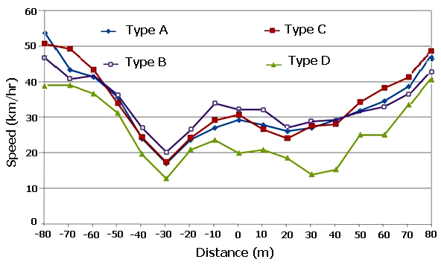
Figure 1: Speeds of various types of vehicles passing a specified point (Times New Roman 12 (using “Figure and Table” style)).

About Figures
Figures are one of the important elements presenting your work. A clear pictorial graphic should be portrayed. Title of Figure is placed beneath the Figure, with sequentially numbered. An example is given in Figure 1. Color border may be used to boost readers’ attention.
In Figure 1, when use “Figure and Table” style, Figure and its title are automatically centered.

Discussion
Text size is Times New Roman 12 (simply use “Normal” from Styles menu). Please be knowing that all articles published in the International Transaction on Engineering & Applied Sciences are licensed under a Creative Commons Attribution 3.0 Unported License (fair use (freely available to "read, download, copy, distribute, print, search, or link", without any charge)). For detail about this, please consult http://creativecommons.org/licenses/by/3.0.

Conclusion
A clear conclusion should be made to summarize + synthesize the study. Text size is Times New Roman 12. The conclusion is often what a reader remembers best. Your conclusion should be the best part of your paper (Wurm and Witchayangkoon, 2010).

Conclusion tells why this paper is important. The authors should tell that your work/idea/concept is meaningful and useful.

Acknowledgements
Acknowledgements topic is put before the References Topic. Times New Roman 12 is used. This topic demonstrates gratitude to various parties involving in development of this article.

References (Alphabet Order, single space)
Satomura, M., Kurt B. Wurm, Paulo C.L. Segantine, and B. Witchayangkoon. (2013). GPS-based Climate Study. International Transaction Journal of Engineering, Management, & Applied Sciences & Technologies, 4(2), 105-124.
Segantine, Paulo C.L. and B. Witchayangkoon. (2012). GNSS + QZSS Test on the Pacific Rims. American Transactions on Engineering & Applied Sciences, 3(1), 35-42.
Wurm, Kurt and B. Witchayangkoon. (2011). Surveying Engineering Development in the Recent Era. American Transaction on Engineering, & Applied Sciences, 2(4), 315-321.

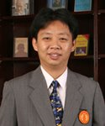 | B. Witchayangkoon is an Associate Professor of Department of Civil Engineering at Thammasat University. He received his B.Eng. from King Mongkut’s University of Technology Thonburi with Honors in 1991. He continued his PhD study at University of Maine, USA, where he obtained his PhD in Spatial Information Science & Engineering. Dr. Witchayangkoon current interests involve applications of emerging technologies to engineering.
 | Paulo Cesar Lima Segantine earned his Ph.D. in Transportation Engineering from the University of São Paulo in 1995. He is currently Associate Professor, University of São Paulo. He has published 22 articles in professional journals and 57 papers in conference proceedings. He published two books and is currently organizing three more books with themes: Basis of Geomatics, Theory of Errors and Geographic Information System. He participated in 13 events abroad and 22 in Brazil. He supervised 17 dissertations and doctoral theses in six areas of Geosciences, Civil Engineering and Mathematics. He works in the area of civil engineering, with emphasis on transport infrastructure. He focuses on GPS (Global Positioning System), GIS (Geographic Information System), neural network, geomatics, cartography, leveling, trigonometric leveling, geodetic networks and geoid models.

